

The Islamia University of Bahawalpur
Bahawalnagar Campus

Final Term Project Report

Topic

ATTENDANCE MANAGEMENT SYSTEM USING FACE RECOGNITION

By

Abdul Qadeer F24NDOCS7M08008

Supervisor
Sir Abdul Rehman

Bachelor of Science in Computer Science (2024-2026)

Table of Contents
Chapter 1 4
Introduction 4
Overview 4
Background 4
Problem Statement 4
Objectives 4
System Requirements 5
Chapter 2 5
Literature Review 5
Overview 5
Existing Attendance Systems 5
Limitations of Traditional Systems 5
Chapter 3 6
Proposed System 6
Overview 6
Key Features 6
Workflow of the Proposed System 6
Chapter 4 7
System Architecture 7
Overview 7
Architecture Components 7
Architecture Diagram 7
Chapter 5 8
Methodology 8
Overview 8
Dataset Creation 8
Preprocessing 8
Feature Extraction 8
Classification 8
Flowchart 8
Chapter 6 10
Implementation Details 10
Overview 10
Modules Description 10
Libraries Used 10
Chapter 7 10
Algorithms Used 10
Face Detection: Haar Cascade Classifier 10
Chapter 8 11
Results And Output 11
Registration Output 11
Training Output 11
Attendance Output 11
Performance Evaluation 11
Chapter 9 11
Advantages And Applications 11
Advantages 11
Applications 11
Chapter 10 12
Limitations And Future Enhancements 12
Limitations 12
Future Enhancements 12
Chapter 11 12
Conclusion 12
References 13

Chapter 1

Introduction

Overview
In the present digital era, automation has become a key requirement for improving operational efficiency in educational institutions and organizations. Attendance management is a fundamental administrative task that directly affects discipline, performance monitoring, and record accuracy. Conventional attendance methods such as manual roll calls and paper-based registers are inefficient, error-prone, and vulnerable to manipulation.
To overcome these limitations, this project presents an Attendance Management System using Face Recognition, which leverages computer vision and machine learning techniques to automate the attendance process in a contactless and secure manner.

Background
Traditional attendance systems require significant manual effort and disrupt teaching or working hours. Biometric systems such as fingerprint scanners provide improved accuracy but involve physical contact, raising hygiene and maintenance concerns. Face recognition technology offers a non-intrusive, scalable, and cost-effective alternative, utilizing existing camera infrastructure and machine learning algorithms to identify individuals uniquely based on facial features.

Problem Statement
The major challenges associated with existing attendance systems include:
- Time Consumption: Manual attendance consumes valuable instructional or operational time.
- Proxy Attendance: Unauthorized marking of attendance for absent individuals.
- Data Management Issues: Physical registers are difficult to store, retrieve, and analyze.
- Human Errors: Manual calculations often lead to inaccurate attendance records.

Objectives
The primary objectives of this project are:
- To develop a contactless automated attendance system using face recognition.
- To accurately identify individuals based on facial features.
- To store attendance data digitally in a structured and easily accessible format.
- To design a user-friendly graphical interface for system administration.

System Requirements
Hardware Requirements
- Webcam
- Minimum 4 GB RAM
- Standard PC or Laptop
Software Requirements
- Operating System: Windows
- Programming Language: Python 3.x
- Libraries: OpenCV, NumPy, Pandas, Tkinter, Pillow

Chapter 2

Literature Review

Overview
Various attendance systems have been developed to improve efficiency and accuracy. Each approach offers certain advantages but also presents limitations that restrict its practical adoption.

Existing Attendance Systems
- RFID-Based Systems: Fast and automated but prone to card sharing and misuse.
- Fingerprint-Based Systems: High accuracy but require physical contact and may fail due to sensor issues.
- Iris Recognition Systems: Extremely accurate but costly and intrusive.

Limitations of Traditional Systems
Manual systems lack reliability and scalability, while biometric systems often require expensive hardware. Face recognition offers an optimal balance by utilizing standard cameras and machine learning algorithms, making it economically viable and technologically efficient.

Chapter 3

Proposed System

Overview
The proposed system is a desktop-based application that automates attendance using real-time face recognition. It consists of three major operational phases:
- Face Registration
- Model Training
- Face Recognition and Attendance Logging

Key Features
- Real-Time Face Recognition
- Automated Attendance Logging
- CSV-Based Data Storage
- Graphical User Interface (GUI)
- Reduced Proxy Attendance

Workflow of the Proposed System
- User registration and face image capture
- Image preprocessing and grayscale conversion
- Feature extraction using LBPH (Local Binary Pattern Histogram)
- Model training and storage
- Live face recognition and attendance marking

Chapter 4

System Architecture

Overview
The system architecture follows a modular design, ensuring separation of functionality and ease of maintenance. Each module operates independently and communicates through structured data flow.

Architecture Components
- Image Acquisition Module: Captures real-time video using webcam.
- Face Detection Module: Detects faces using Haar Cascade classifier.
- Face Recognition Module: Identifies faces using the LBPH algorithm.
- Data Storage Module: Stores attendance records in CSV files.

Architecture Diagram
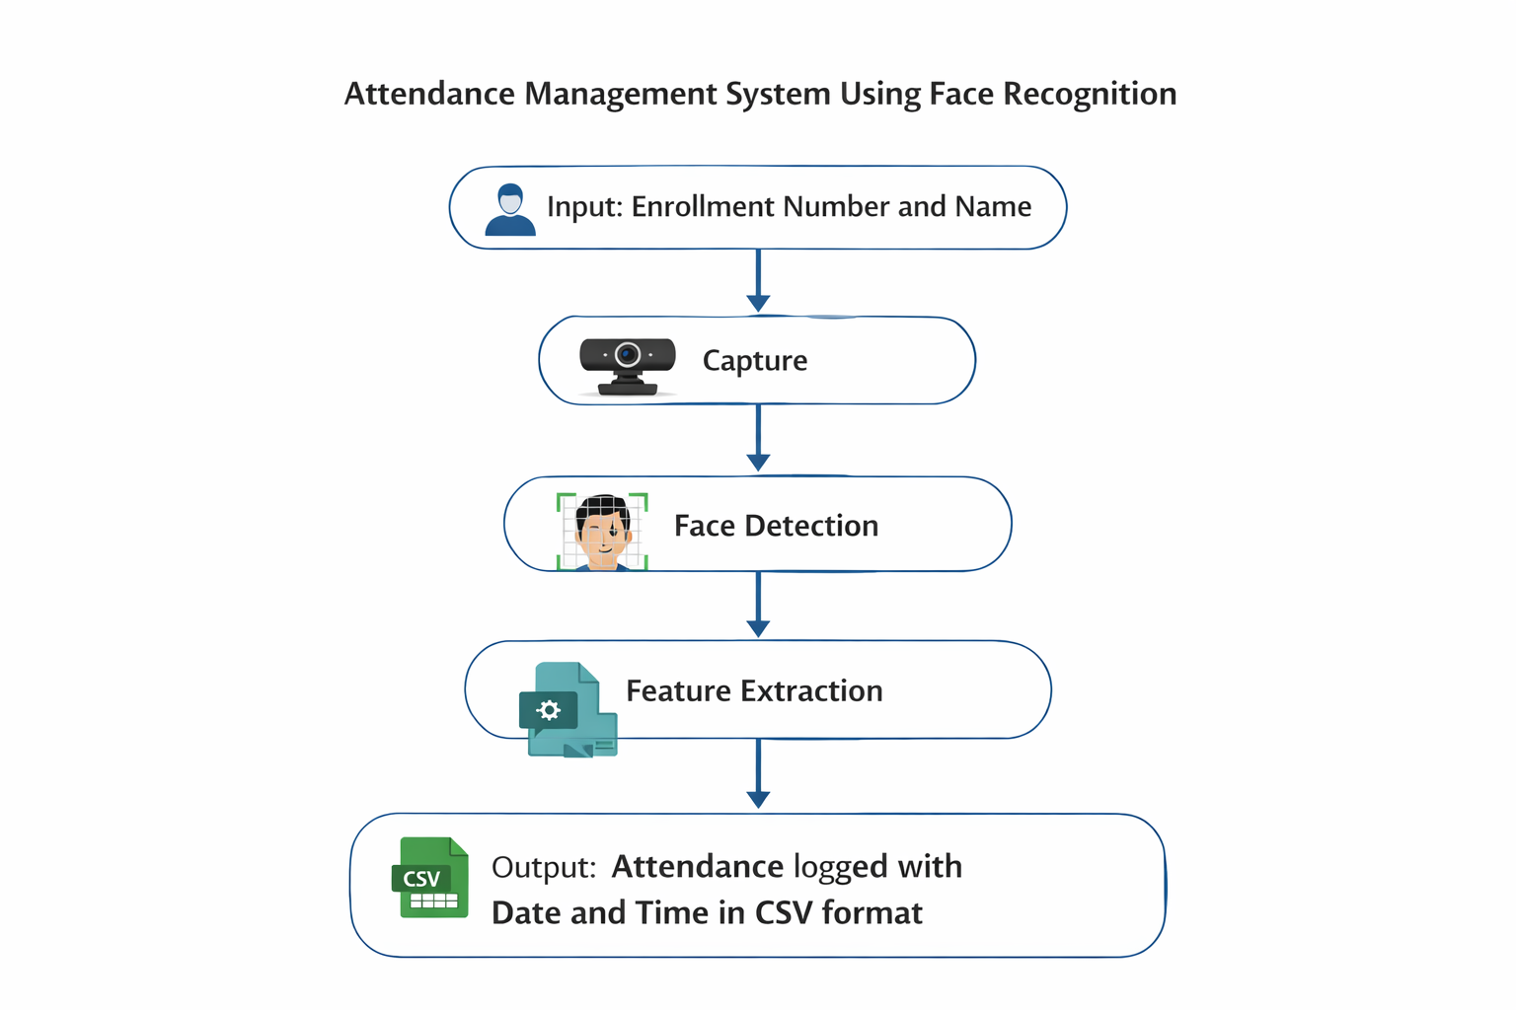

Chapter 5

Methodology

Overview
The system follows a supervised machine learning pipeline, where labeled facial images are used to train the recognition model.

Dataset Creation
Multiple facial images (50 samples) are captured per user during registration. These images are stored in grayscale format and labeled with a unique Enrollment ID.

Preprocessing
Images are converted to grayscale to reduce computational complexity. Histogram equalization may be applied to handle illumination variations.

Feature Extraction
Facial textures are extracted using Local Binary Patterns (LBP), which encode local pixel relationships into binary patterns.

Classification
The trained LBPH model predicts the Enrollment ID of detected faces. If the confidence score is within the acceptable threshold, the identity is confirmed.

Flowchart

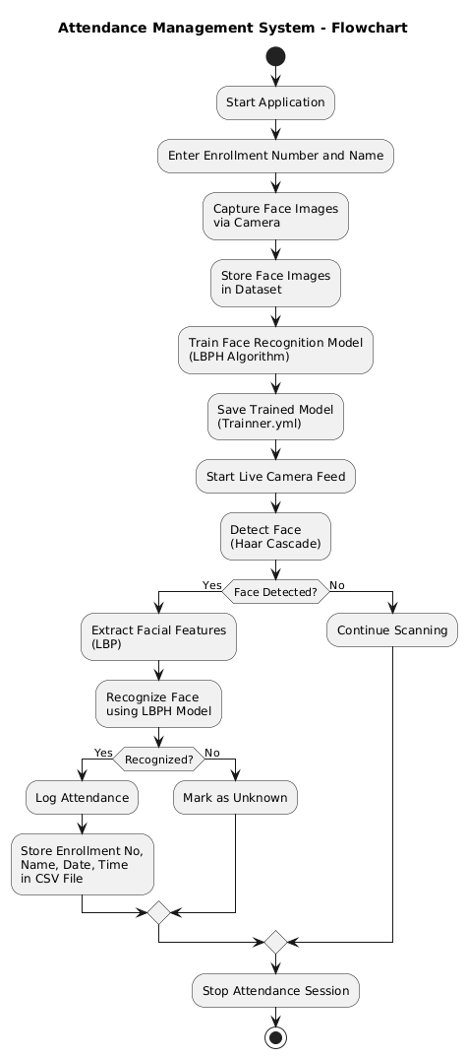

Chapter 6

Implementation Details

Overview
The system is implemented using Python and integrates multiple modules to perform registration, training, and recognition.

Modules Description
- takeImage.py: Captures facial images and stores student details.
- trainImage.py: Trains the LBPH model and generates Trainner.yml.
- automaticAttendance.py: Performs real-time recognition and attendance marking.
- attendance.py: Main GUI dashboard linking all modules.

Libraries Used
- OpenCV: Image processing and video capture
- Pandas: CSV file handling
- Tkinter: GUI development
- Pillow: Image rendering in GUI

Chapter 7

Algorithms Used

Face Detection: Haar Cascade Classifier
The Haar Cascade algorithm detects faces using rectangular Haar-like features and a cascade of classifiers trained via AdaBoost.
Why Haar Cascade?
- High speed
- Real-time performance
- Suitable for CPU-based systems

Chapter 8

Results And Output

Registration Output
Users can successfully register by entering ID and Name. The system captures facial samples and confirms storage.
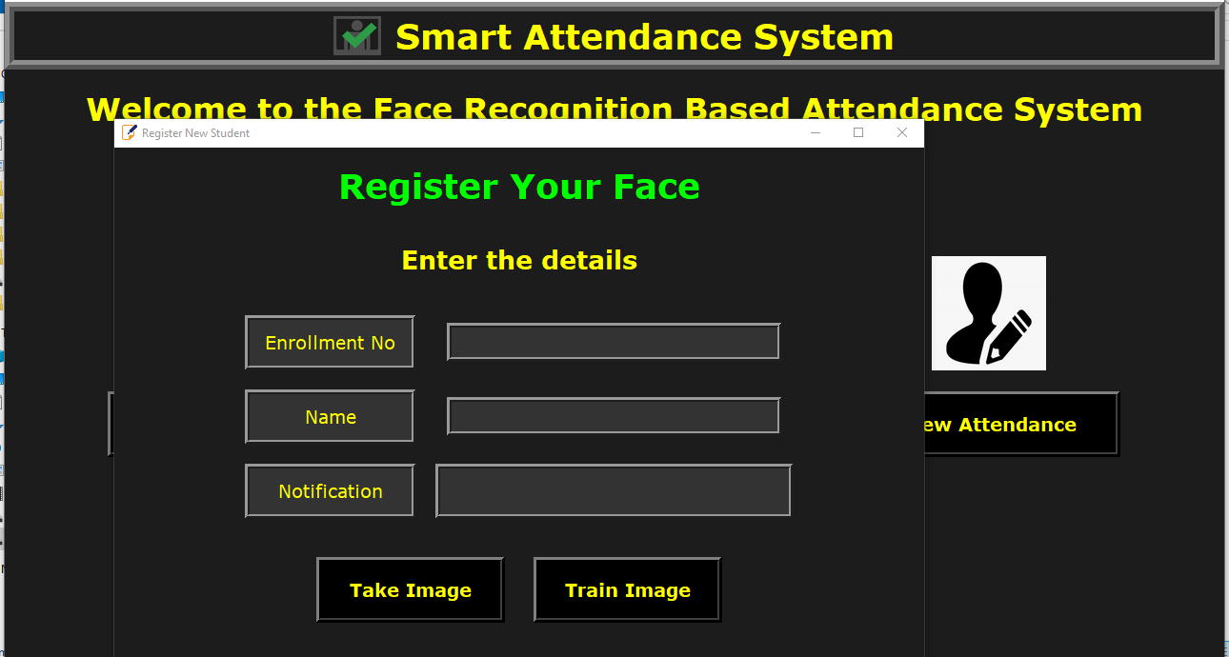

Attendance Record
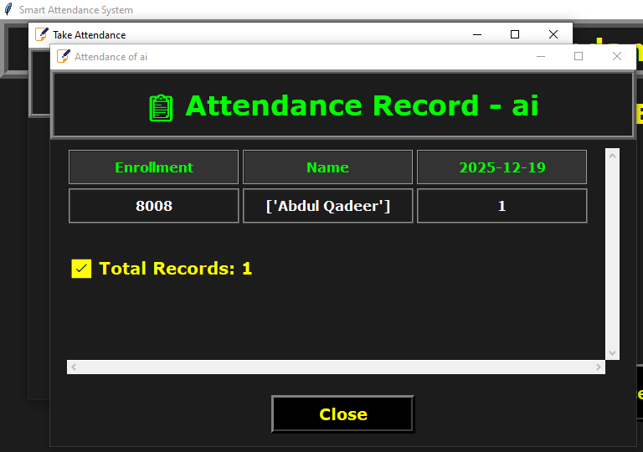

Attendance Report


Training Output
The LBPH model is trained successfully, and the trained model file is generated.

Attendance Output
- Recognized Face: Green bounding box with ID and Name.
- Unknown Face: Red bounding box labeled “Unknown”.

Performance Evaluation
The system achieves an average recognition accuracy of 85–90% under controlled lighting conditions.

Chapter 9

Advantages And Applications

Advantages
- Reduces manual effort
- Improves accuracy
- Cost-effective solution
- Digital and searchable records

Applications
- Educational institutions
- Corporate offices
- Security access control
- Event management

Chapter 10

Limitations And Future Enhancements

Limitations
- Sensitive to lighting variations
- Limited performance for non-frontal faces
- Possible confusion with similar facial features

Future Enhancements
- Integration of deep learning models (CNNs)
- Cloud-based attendance storage
- Liveness detection for anti-spoofing

Chapter 11

Conclusion
The proposed Attendance Management System using Face Recognition effectively automates the attendance process using machine learning and computer vision techniques.
The system demonstrates improved efficiency, accuracy, and reliability compared to traditional methods. While certain limitations exist, the project provides a strong foundation for future intelligent attendance and identity management systems.

Chapter 12

References
- P. Viola and M. Jones, “Rapid Object Detection Using a Boosted Cascade of Simple Features,” IEEE CVPR, 2001.
- T. Ahonen et al., “Face Description with Local Binary Patterns,” IEEE TPAMI, 2006.
- OpenCV Documentation, Face Recognition Module.
- G. Bradski, “The OpenCV Library,” Dr. Dobb’s Journal.
- Kaggle.com
- Github.com

